PERIODIC TEST -2 (2022 – 2023)
NAME: ______________ GRADE: 6
SUBJECT: ENGLISH DATE:26.08.2022
TIME: 1 ½ HOURS TOTAL MARKS: 40
I. Read the poem given below and answer the questions: (5x1=5)
The Echoing Green
BY WILLIAM BLAKE
The sun does arise,
And make happy the skies.
The merry bells ring
To welcome the Spring.
The sky-lark and thrush,
The birds of the bush,
Sing louder around,
To the bells’ cheerful sound.
While our sports shall be seen
On the Echoing Green.

Old John, with white hair
Does laugh away care,
Sitting under the oak,
Among the old folk,
They laugh at our play,
And soon they all say.
‘Such, such were the joys.
When we all girls & boys,
In our youth-time were seen,
On the Echoing Green.’

Till the little ones weary
No more can be merry
The sun does descend,
And our sports have an end:
Round the laps of their mothers,
Many sisters and brothers,
Like birds in their nest,
Are ready for rest;
And sport no more seen,
On the darkening Green.
Answer the following questions:

1. Which are the two birds in the poem?

2. Which words from the first stanza create a cheerful mood?

3. What happens when the sun arises?

4. In the last stanza, what time of day is it?

5. In the last stanza, what happens to the children?

II. Picture writing: (1x5=5)
A) Look at the pictures given below and write a paragraph with the help of prompt words for 100 -150 words. Give a title to your passage.
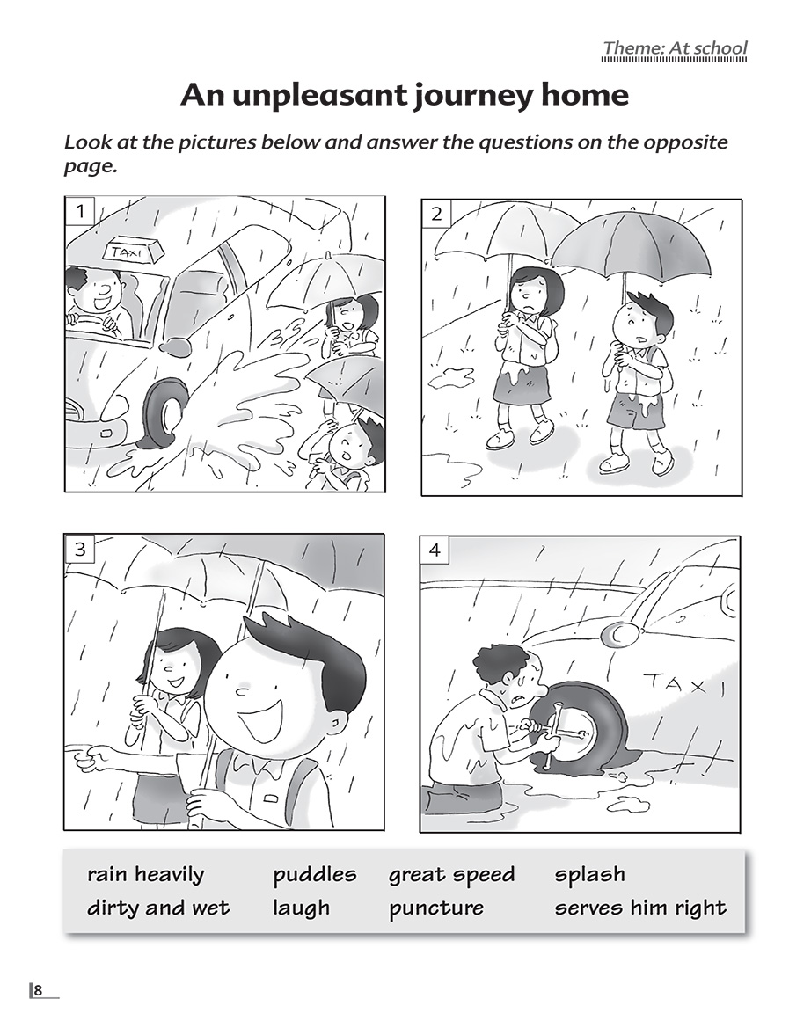

B) Find any eight words from the following picture. (8×1/2=4)
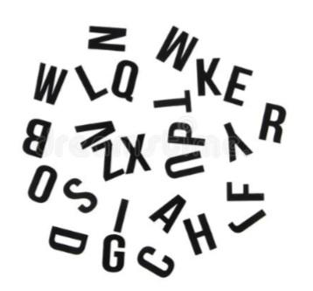

III. GRAMMAR
A) Rewrite these sentences by changing the underlined words to that of the opposite gender. (3x1=3)
8. Who is your favorite actor?
9. I am going to meet my friend's grandmother.
10. The policeman was tired after working the entire day.
B) Fill in the blanks with the noun forms mentioned in the bracket: (2x1=2)
11.Are _________________ and you going to the market today? (common noun)
12. My friend has invited me to her house for _________________. (proper noun)
C) Spot the error: (2x2=2)
13. Ramu is a honest man.
14. Bread and butter are Sheldon’s favourite breakfast.
IV. LITERATURE:
A) Read the poem lines given below and answer the question: (4x1=4)
“The Poetry of earth is never dead:
When all the birds are faint with the hot sun,
And hide in cooling trees, a voice will run
From hedge to hedge about the new-mown mead;
That is the Grasshopper’s—he takes the lead”

15. Who wrote the above poem?
16. Mention the literary device used in the above lines with an example from the poem.
18. Identify the rhyme scheme used in the above lines.
19. “On the Grasshopper and the Cricket”- is divided into two parts. What are they?

B) Answer the following question- 75 to 80 words:(Any 5) (5x3=15)

20. How does the poet contrast the lives of the Cricket and the Grasshopper?
21. What is the best season for vegetation? Where did Rakesh go during that season?
22. What are the qualities of amber beads? How was Jeanie’s amber different from others?
23. Why there is not many fruit trees in Rakesh’s place?
24. Describe Jeanie’s look.
25. “The story of Amber beads” is set in Scotland. State at least three instances to prove this.

